RECOGNITION OF HUMAN IRIS PATTERNS FOR BIOMETRICS IDENTIFICATION

¹ VIJAYSINH T. JADEJA, ² DR.J.G.PANDYA

¹ Murlidhar Group of Institutions , Rajkot, Gujarat, India
² EX. Manager, BISEG,Gandhinagar, Gujarat, India

mgi.vijaysinh@gmail.com, pandyajg@yahoo.com

ABSTRACT : A biometrics system Provides automatic identification of an individual based on a unique future or characteristic possessed by individual iris recognition is regarded as the most reliable and accurate biometric identification system available. The biometrics person authentication technique based on the pattern of the human iris is well suited to be applied to any access control system requiring a high level of security. Iris recognition is regarded as the most reliable biometrics and has been widely applied in both public and personal security areas. However users have to Highly cooperate with the iris cameras to make his iris Images well captured. The localized iris image is transformed from Cartesian to polar co-ordinate system to handle different size, variation in illumination and pupil dilation.

Keywords: Biometrics, Iris Detection, Camera-Ready Format,

1. INTRODUCTION
With an increasing emphasis on security, automated personal identification based on biometrics has been receiving extensive attention over the past decade. Biometrics aims to accurately identify each identification using various physiological or behavioral characteristics such as fingerprint, iris, face, retina, and hand geometry etc; recently iris recognition is becoming an active topic in biometrics due to its high reliability for person identification. The human iris, an annular part

between the pupil ( generally appearing black in an image ) and the white sclera as shown in Fig 1. Has an extraordinary structure and provides many interlacing minute characteristics such as freckles, coronas, stripes, furrows, crypts and so on, these visible characteristics, generally Called the texture of iris, are unique to each subject. The uniqueness o the iris pattern is the direct result of the Individual differences that exist in the development of the automatically structures in the body.

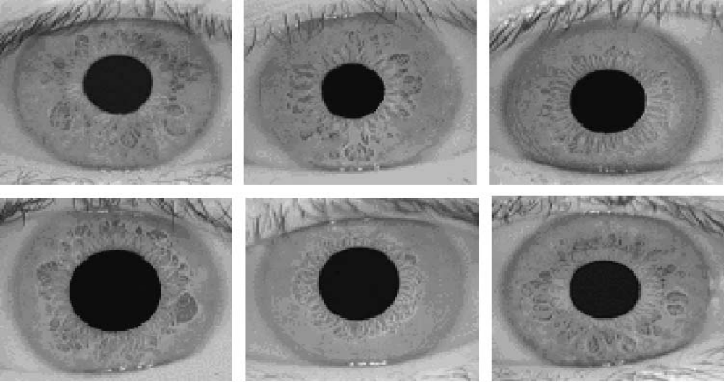.
Fig. 1. Samples of iris images.

The iris is essentially stable over a person’s life. Furthermore, since the iris is an internal organ as well as externally visible, iris-based personal identification systems can be noninvasive to their users which are of great importance for practical applications. All these desirable properties (i.e., uniqueness, stability, and noninvasiveness) make iris recognition a particularly promising solution to security.
2. IRIS RECOGNITION
In spite of the specificities of the different proposals, typical iris recognition algorithms share the Structure given in figure 2.

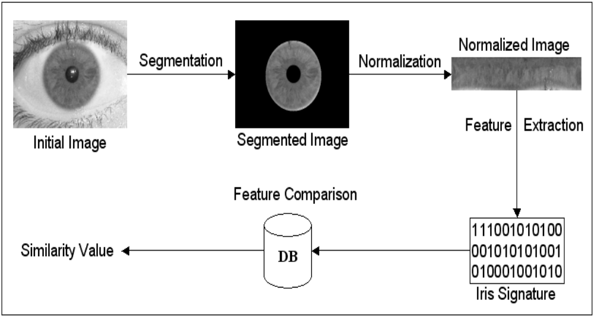

Figure 2. Typical stages of iris recognition.

The initial stage deals with iris segmentation, which is usually performed through the use of a Rigid or deformable iris template In order to compensate the variations in pupils size and in the image capturing distances, the segmented iris region is translated into a double dimensionless polar coordinate system, through a method (Daugman Rubber Sheet) proposed by Daugman Regarding feature extraction, published approaches can be divided into three major categories: phase-based methods , zero crossing methods and texture analysis based methods, Finally, the comparison between iris signatures is performed and produced a numeric dissimilarity value. If this value is higher than a threshold, the system outputs a non-match, meaning that each signature belongs to different irises. Otherwise, the system outputs a match, meaning that both signatures were extracted from the same iris. Here, it is usual to apply distance metrics (Hamming, Euclidean, Weighted Euclidean) or methods based on signal correlation.
3. IMAGE ACQUISITION
In iris recognition image acquisition is an important step. Since iris is small in size and dark in color, it is difficult to Acquire good image. Also all the subsequent steps depend on it. A Panasonic camera has been used to take eye snaps while trying to maintain appropriate settings such as lighting, distance to the camera and resolution of the image. The image is then changed from RGB to gray level for further processing.
4. IRIS SEGMENTATION
Iris segmentation deals with extracting the iris region from the eye image. It is the most important stage in iris recognition system as it has pronounced effect on the post processing steps such as normalization, feature extraction, matching and recognition rates. Sometimes iris portion is partially occluded with eyelashes and eyelids, also secular reflection takes place near the pupil when imaging under natural light. All these artifacts need to be removed as it corrupts the important portion of iris patterns and thus leading the false recognition rates. Iris segmentation can be done using main steps: (I) determination of inner iris radius, (ii) outer iris localization, (iii) eyelids detection, (IV) eyelashes detection.

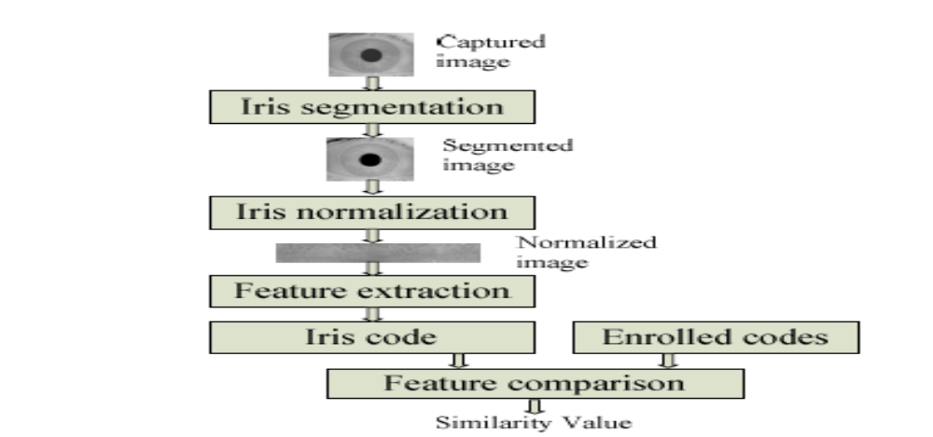
Block Diagram of general iris recognition system

5. IRIS NORMALIZATION
Iris of the different people may be captured in different size, the size of iris and pupil may vary for the same persons because of variation in illumination and other factors. This deformation of iris can cause interference with the results of pattern matching. So, to reduce this interference, next step in the system is iris normalization. In this steps the iris Patterns are translated into fixed length and dimensionless polar coordinate system in order to compensate the variations in the pupil size, rotation of camera, head tilt, varying imaging distance and to allow comparisons of iris images. Normalization represents the iris data invariant to the dimensions of the captured image so that two images of same iris under varying conditions will have characteristic features at same spatial locations. J. G. Daughman has given very popular Rubber Sheet model for iris normalization. We have used his method for normalizing partial iris.
6. IRIS FEATURE EXTRACTION
In the feature extraction steps, the most important features of the iris such as crypts, collarets, radial and contraction furrows which are in the form of texture patterns are extracted so that comparisons between templates can be made. The features are encoded to a format suitable for recognition. Different methods of Feature extraction are 2-D Gabor wavelet, Laplacian of Gussian filters, and Log- Gabor filters, Haar wavelet. I have used Gabor Wavelet for extracting unique features of iris.
7. CONCLUSION
Iris recognition as a biometric technology has great advantages such as variability, stability and security. Thus it will have a variety of applications a person

authentication technique using human iris recognition is presented. A method of evaluating the quality of an image in the image acquisition step and excluding it from the subsequent processing if it is not appropriate. A computer graphics algorithm for detecting the centre of the pupil and localizing the iris area from an eye image. Transforming the localized iris area into a simple coordination system.
8. REFERENCES
[1] Daugman, How iris recognition works, IEEE Trans. Circuits Syst. Video Technol., 14(1): 21-30, 2004
[2] J.G.Daugman, “High confidence visual recognition of persons by a Test of statistical independence,” IEEE Trans. Pattern Anal. Mach. Intell. vol. 15, no. 11, pp. 1148–1161, Nov. 1993.
[3] R. Johnson, “Can iris patterns be used to identify people?” Chemical And Laser Sciences Division LA-12 331-PR, Los Alamos Nat. Lab., Los Alamos, CA, 1991.
[4]J.Daugman, “Statistical Richness of Visual Phase Information: Update on Recognizing Persons by Iris Patterns”, International Journal of Computer Vision, Vol.45 (1), pp.25-38, 2001.
[5] Daugman, J. “How Iris Recognition Works”, available at http://www.ncits.org/tc_home /m1htm/docs/m1020044.pdf.
[6] S.E. Umbaugh, “Computer Vision and Image Processing: A practical approach using CVIP tools” NJ: Prentice-Hall, 1998.
[7] W.W. Boles and B. Boa shah, “A Human Identification Technique Using Images of the Iris and Wavelet Transform” IEEE Trans. on Si gnal Processing, vol.46, pp. 1185-1188, April 199

