STUDY ON MACHINABILITY OF METAL MATRIX
COMPOSITES IN TURNING: A REVIEW

¹ PATEL P.R., ²PATEL V.A.

¹Student of Master of Engineering (Cad-Cam), Sankalchand Patel College of Engineering, Visnagar, Gujarat, 384 315.
² Mechanical Engineering Department, Sankalchand Patel College of Engineering, Visnagar, Gujarat, 384 315.

pragneshpatel27@yahoo.com, vapatel.mech@spcevng.ac.in

ABSTRACT: Metal matrix composites are new class of metal composites which offers superior properties over alloys. Therefore this material has recently been used in several applications in aerospace and automotive industries. Problem associated with MMCs is that they are very difficult to machine due to the hardness and abrasive nature of Carbide particles. The Main objective of this paper is to study the effects of different cutting parameters (Cutting Speed, feed rate, Depth of cut) on Surface roughness and tool Wear in turning of MMCs. The review begins with a brief introduction on MMCs. Research in Machining of MMCs is grouped broadly. The problems and challenges in machining of metal matrix composites are discussed with relation to different cutting parameter on Surface roughness, and tool Wear. A summary of the future research directions based on the review is presented at the final section.

Keywords: Metal Matrix Composites (MMCs), PCD tool, Surface roughness, tool wear

1. INTRODUCTION
Metal matrix composites consist of at least two chemically and physically distinct phases, suitably distributed to provide properties not obtainable with either of the individual phases. fibrous or particulate phase in the form of continuous, discontinuous fiber, whiskers, Particles, distributed in a metallic matrix which include light metal such as aluminum, magnesium, titanium, copper, and their alloy[1,2].
In general, Metal matrix composites are classified into two ways.
1 Discontinuously reinforced MMCs
2 Continuous fiber or sheet reinforced MMCs

1. Discontinuously reinforced MMCs
There are two types of discontinuous reinforcement for MMCs: (1) particulate reinforced MMCs and (2) whiskers reinforced MMCs. The most common type of whisker is Silicon carbide, but Whiskers of alumina and silicon nitride have also been produced; Fig 1.1 shows whisker reinforced MMCs [19]. The most common types of particulate are alumina, boron carbide, silicon carbide, titanium carbide, and tungsten carbide. Fig 1.2 shows particulate reinforced MMCs.
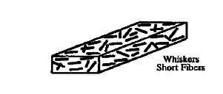
Fig No: 1.1 whisker Reinforced MMCs
In terms of tailorability, a very important advantage in MMC applications, particulate reinforcement offers various desirable properties. Boron carbide and silicon carbide, for instance, are widely used; inexpensive, commercial abrasives that can offer good wear resistance as well as high specific stiffness. Titanium carbide offers a high melting point and chemical inertness which are desirable properties for processing and stability in use. Tungsten carbide has high strength and hardness at high temperature [19].
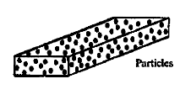
Fig No: 1.2 Particles Reinforced MMCs

Mechanical properties of Composite material such as stiffness, strength is increase as increase in length of reinforcement. Particulate-reinforced composites are isotropic, having the same mechanical properties in all directions; whiskers should confer superior properties because of their higher aspect ratio, (length divided by diameter). However, whiskers are ‘brittle
and tend to break up into shorter lengths during processing. This reduces their reinforcement efficiency, and makes the much higher cost of whisker reinforcement. Another disadvantage of using whisker reinforcement is that whiskers tend to become oriented by some processes, such as rolling and extrusion, producing composites with different properties in different directions, it is also more difficult to pack whiskers than particulate, and thus it is possible to obtain higher reinforcement: matrix ratios with particulate. Higher reinforcement percentages lead to better mechanical properties
Such as higher strength [19].
2. Continuous reinforced MMCs
Fiber reinforcement, by far the most common kind of
Continuous reinforcement, many types of fibers are used; most of them are carbon or ceramic. Carbon
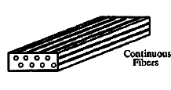
Fig 1.3 Fibers reinforced MMCs
types are referred to as graphite and are based on pitch or polyacrylonitrile (PAN) precursor. Ceramic types include alumina, silica, boron, alumina-silica, alumina-boriasilica, zirconia, magnesia, mullite, boron nitride, titanium diboride, silicon carbide, and boron carbide. All of these fibers are brittle, flaw-sensitive materials. As such, they exhibit the phenomenon of size effect; Fig 1.3 shows Fiber reinforced MMCs [19].
Many materials when they are in a fibrous form exhibit very good strength Property but to achieve these properties, the fibers should be bonded by a suitable matrix. the matrix functions include binding the fibers together, protecting fibers from the environment, shielding from damage due to handling,
and distributing the load to fibers. The matrix isolates the fibers from one another in order to prevent abrasion and formation of new surface flaws and acts as a bridge to hold the fibers in place. A good matrix should possess ability to deform easily under applied load, transfer the load onto the fibers and evenly distributive stress concentration [5]. Fig 1.4 shows the microstructure of MMCs in which Reinforcement material is holded by matrix of metal.

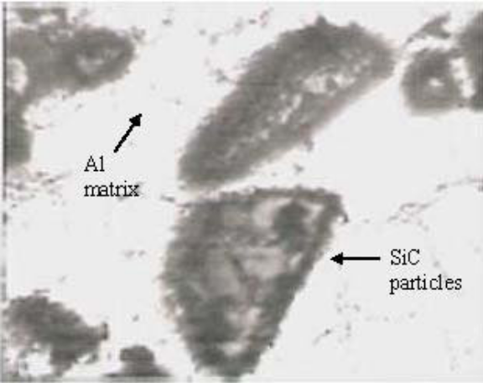
Fig No: 1.4 Microstructure of MMCs
Reinforcement materials for metal matrix composites can be produced in the form of continuous fibers, short fibers, whiskers, or particles. The role of the reinforcement in a composite material is fundamentally one of increasing the mechanical properties of the neat resin system.
All of the different fibers used in composites have different properties and so affect the properties of the composite in different ways [1].Table 1.1 provides examples of some important reinforcements used in metal matrix composites as well as their aspect ratios (length/diameter) and diameters.

Table: 1.1. Typical Reinforcements Used in Metal Matrix Composites
Type | Aspect Ratio | Diameter, µm | Examples
Particle | 1- 4 | 1- 25 | Sic, Al₂0₃, BN,  B₄C, WC
Short fiber or  whisker | 10- 10000 | 1- 5 | Al₂0₃+Si0₂  C,SIC, A1₂0₃
Continuous fiber | >1000 | 3 - 150 | Sic,Al₂0₃, C,B,W,Nb Ti, Nb3Sn

The main attractive features of the MMCs are high strength to Weight ratio, Excellent Mechanical and thermal properties over conventional material and alloy, improved fatigue and creep characteristics, better wear resistance [4]. These properties have made these materials an excellent candidate to manufacture a wide range of products from aerospace parts to sports goods. MMCs are very difficult to cut. Because of hard and abrasive nature of carbide particles, MMCs are shown to cause excessive tool wear, which in turn induces such damage phenomena as fiber pullout, particle fracture, delaminating and deboning at the fiber or particle and matrix interface. The parameters that are the major contributors to the machinability of these composites are the reinforcement type and orientation, tool type and geometry and the machining parameters [3]. It have been found that global MMC market will rise from 3.6 million kg in 2005 to 4.9 million kg by 2010 reflecting an average annual growth rate about 6.3 % [4].

2. PAST RESEARCH IN MACHINING OF MMCs
This section will provide an overview of researches on the effect of different cutting parameters and different reinforcement particles size and distribution on extrinsic parameters during turning of MMCs.
Rajesh Kumar Bhushan et al.(2010) has investigated the effect of cutting speed, depth of cut, and feed rate on surface roughness and tool wear rate during machining of 7075 Al alloy and 10 wt.% SiC particulate metal-matrix composites. tungsten carbide and polycrystalline diamond (PCD) inserts have been used as cutting tools.

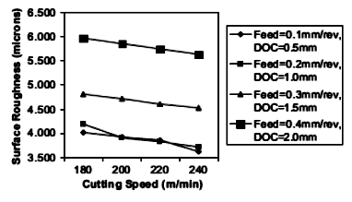
Fig. 2.1 Variation of surface roughness of Al alloy using carbide insert

It has been found that Surface roughness of Al alloy is decrease with increase in cutting speed in all cutting condition. From figure 2.1 it have seen that as the feed rate is decreased from 0.4 to 0.1 mm/rev. surface roughness is decreased from 6 µm to 4 µm at the cutting speed of 180 m\min. Surface roughness obtained by PCD tool insert is less as compare to carbide insert at the same cutting condition as shown in Fig 2.1 and Fig 2.2.

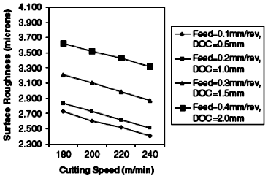
Fig. 2.2 Variation of surface roughness of Al alloy using pcd insert
With the cutting speed of 180 m\min, feed rate of 0.4 mm\rev, and depth of cut of 2.0 mm, surface roughness obtained by carbide tool insert is 6.0 µm and for PCD insert 3.7 µm. As the cutting speed is increased, Flank wear of both of the tool insert is increased as shown in Fig 2.3 & Fig 2.4. From figure it has seen that flank wear is increased with increasing in feed rate and depth of cut in all cutting condition. Wear of PCD insert is less as compared to wear of carbide insert as shown in Fig 2.3 and Fig 2.4. At the feed rate of 0.1 mm\rev; depth of cut of 0.5 mm with cutting speed of 180 mm\min; flank wear of PCD insert is 0.0030 mm while that for Carbide insert it is 0.06 mm. wear of carbide and PCD inserts is less during turning of Al alloy as compared to Al alloy composite. [6].
Saeed chavosi (2010) has investigated the effects of feed ,depth of cut and cutting speed on flank wear of Tungsten carbide and PCD inserts in CNC turning of 7075 Al Alloy with 10% wt Sic Composites.

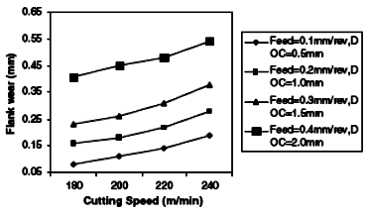
Fig 2.3 Flank Wear of carbide insert with cutting speed

It has been found that increase in feed rate, depth of cut and cutting speed results in increasing in the flank wear. As shown in Fig 2.5, Feed rate is increased from 0.1 to 0.4 mm\rev, flank wear is increased from 0.1 to 0.45 µm. while the cutting speed is increased from 180 to 240 m\min,
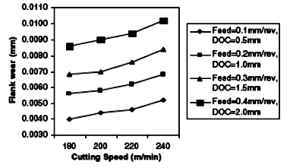

Fig 2.4 Flank Wear of PCD insert with cutting speed

Flank wear is increase from 0.2 to 0.35 mm, from figure 2.5 it has been that feed rate and depth of cut have significant effects on surface roughness while the cutting speed has lesser effect on surface roughness. It has been seen that wear of PCD insert is less as compare to Carbide insert [7].
Ge Yingfei et al.,(2010) has investigated wear pattern and it’s mechanism of SCD (single crystal diamond) and PCD (polycrystalline diamond), in ultra precision turning of MMCs under wet condition, It has been found that Microwear, chipping, cleavage, abrasive wear and chemical wear are the dominating wear patterns of SCD tools and PCD tool mainly suffered from abrasive wear on the rake face and adhesive wear on the flank face. It has been found that SCD tool had best Cutting
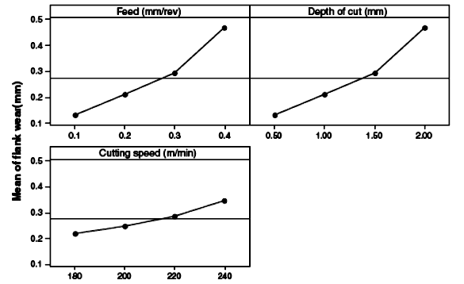

Fig: 2.5 Main effect plots of the cutting parameters on flank wear
Performance, when the PCD tool has steady and favorable cutting performance and could produce acceptable surface roughness [8].
Metin kon (2008) has been investigated machinability of 2024/Al₂O₃ particles composite (MMC_{s}) in CNC turning. Two cutting tool were used namely, TiN (K10) coated carbide tool and HX uncoated carbide tool in different cutting condition, It has been found that the tool life of coated tool is long as compare to uncoated tool for both material (Al alloy and AL-Composite) as shown in Fig 2.6.

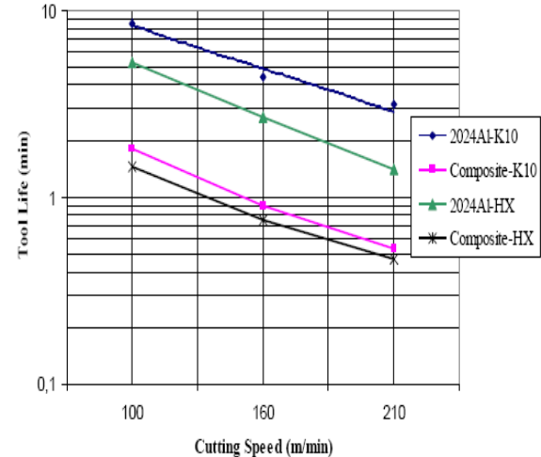
Fig: 2.6 Tool life versus cutting speed
Tool life is decreased with an increase in the cutting speed in all cutting condition. As the cutting speed is increase from 100 m/min to 160 m/min. Flank wear with cutting time of 1 min is increase from 0.2 to 0.3 mm for Composite material using K10 coated tool. While that for HX-uncoated tool insert for composite material, flank wear for the cutting time of 1 min is increased from 0.275 to 0.3 mm with increasing in cutting speed from 100 m/min to 160 m/min [9].
It has been found from Fig 2.7 and Fig 2.8 that tool life of K-10 Coated cutting tool is higher compared to HX uncoated Cutting tool for Al-alloy and Al- Composite. Flank wear rate for AL-alloy is less compare to AL-Composite for both cutting tool.
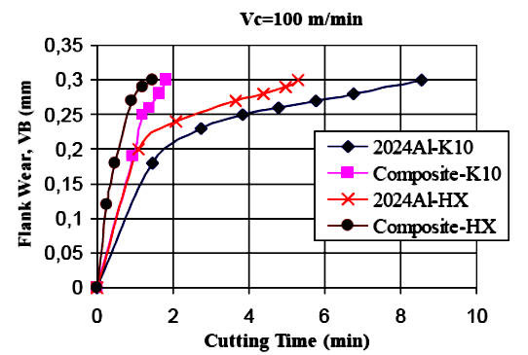

Fig: 2.7 Variation of flank wear as a function of cutting time under cutting speeds of 100 m min⁻¹

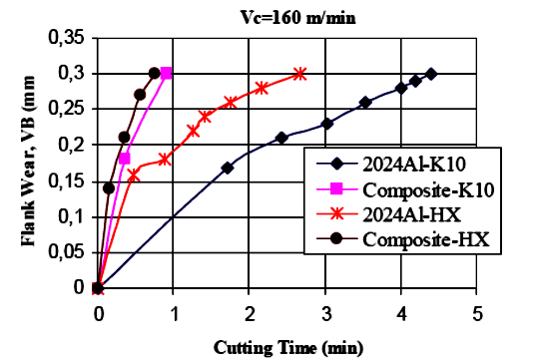
Fig: 2.8 Variation of flank wear as a function of cutting time under cutting speeds of 160 m min⁻¹

M.El-Gallab et al. (1998) investigated the effects of
tool geometry, cutting speed and feed rate on cutting forces and flank wear in turning of A356-20%SiC. It has been found that tool nose radius play important role in finding out flank wear. As the tool nose radius is decreased from 1.6 mm to 0.8 mm, the tool was found to suffer from excessive chipping and crater wear, as shown in Fig. 2.9. It has been also found that flank wear is increased with increase in negative rack angle because of higher cutting force are encountered with such a angle, which allow to produced the chip become caught between the tool and workpiece causing damage to tool surface. By increasing in feed rate, cutting forces are also increased as shown in fig 2.10.
Y.F.Ge et al., (2008) has carried out ultra-precision turning on SiC_{p}/2024 and SiC_{p}/ZL101A composites. It has been investigated surface integrity using two different cutting tool namely Single point Diamond tool and PCD tool under different cutting conditions. It has been also investigated effects of cooling conditions, particles reinforcement’s size and distribution, volume fraction of reinforcement in turning.
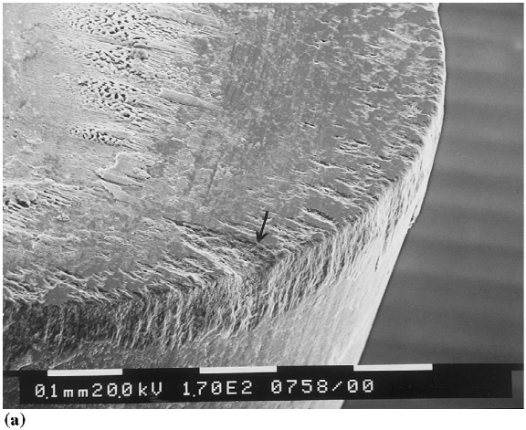

Fig 2.9 SEM image illustrating the PCD tool wear by chipping
It has been found the defects such as pits, voids, microcracks, grooves, matrix tearing on turned surface due to the course of Sic particles being removed during precision. By increase the feed rate, poor surface finish was generated; because of more SiC particles were pulled out and crushed, By provided coolant, Cutting temperature and tool wear was decrease. By providing positive tool Cutting edge inclination and zero rack angle, Lower surface roughness value can be produced [10].
Pramanik et al., (2006) prepared mechanics model for predicting the forces of cutting aluminum-based SiC/Al₂O₃ particle reinforced MMCs, three factors has been considered which are responsible for force generation mechanism which of them are chip formation force, ploughing force, particle fracture force. It has been found that the force due to chip formation is much higher than those due to ploughing and particle fracture [11].
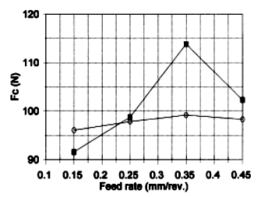
Fig 2.10 Effect of feed rate on Cutting force

R.Venkatesh et al. (2009) has been investigated machinability of A356 – Sic (20_{p}) metal matrix composites using PCD cutting tool. It have been investigated the effects of different cutting parameters on power consumption, surface roughness and material removal rate in turning of MMCs. From experiment, it has been found that value of surface roughness is decrease with increase in cutting speed in all cutting condition. power consumption is increase with increase in cutting speed as well as feed rate as shown in fig 2.11. Material Removal rate is increase in increase in Cutting speed with the all value of depth of cut.
Ibrahim ciftci et al. (2004) has investigated effects of cutting speed and effect of coating on tool wear during turning of Al-2014 alloy matrix composite. Feed rate and depth of cut were kept constant. Coated carbide and uncoated carbide tool were used as cutting tool. It has been found that cutting speed, reinforcement particles size and it’s weight fraction are the main responsible factor for occurrence of tool wear. Wear rate of coated tool is less than uncoated cutting tool. Uncoated cutting tool produced better surface finish at lower cutting speed but at higher speed it produced poor surface finish [13].

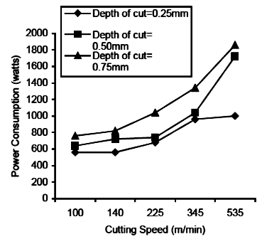

Fig 2.11 Graph of Power Consumption Vs Cutting speed
R. Ramanujam et al. (2010) investigated effect of cutting parameters on power consumption and Surface roughness using Desirable function analysis. It has found that power consumption is increase with increase in cutting speed in all cases. For the same cutting speed, power consumption is increase in increase in feed rate [21].
Summary of above study realized that machining of MMCs is difficult. To obtained high surface finish, cutting speed should be required which is resulted in high tool wear on cutting tool insert and resulted in high tool costing.

3. CURRENT RESEARCH TRENDS IN MACHINING OF MMCs

In recent years, different reinforcement materials are used in fabrication of metal matrix composites. Among them, Sic is widely used as a reinforcement material in the matrices of Aluminum, it have been realized from past research that Experimental investigation of discontinuous reinforced MMCs have been done with different reinforcement materials, but Still research have not be done on Continuous Reinforcement material. Machinability behavior of AL-Sic (MMCs) have been studied with relation to surface roughness, cutting tool performance but still work has not been done in turning of MMCs in which titanium carbide is used as a reinforcement material.

4. FUTURE DIRECTION OF RESEARCH

Future advancement in the area of machining of metal matrix composite will continue towards understanding the fundamental of machining of MMCs as broadening the application of the process for the industries. Following is a list summarizing the future research opportunities, Challenges and guidelines in the area of Machining of metal matrix composites.
- Fundamental understanding machining of metal matrix composites
- The development of newer cutting tool having ideal cutting tool properties.
- Investigation of machinability behavior in turning of Al-Tic (MMCs) and cutting tool performance during turning.
- Experimental investigation of Continuous Reinforced MMCs.

5. REFERENCES

- N.chawla, K.K. chawla,“Metal matrix composites” Springer(2006).
- Y.Sahin, G. Sur. “The effect of AL2O3, TiN and Ti based CVD coating tools on wear in machining metal matrix composites” Surface and coating Technology” (2003) 179:349-355.
- J Paulo Davim (2011), “Machining of Metal Matrix Composites”.
- N.chawla, K.K chawla, “Metal matrix composites in ground Transportation” Journal of manufacturing (2006) 67-70.
- Autar K. Kaw, “Mechanics of composite Material” Taylor &Francis Group (2006).
- Rajesh Kumar Bhushan, Sudhir kumar ,S.Das, “Effect of machining parameters on surface roughness and tool wear for AL alloy Composite” International Journal of Advance manufacturing Technology(2010) 50: 459-469.
- Saeed Zare Chavoshi,“Tool flank wear prediction in CNC turning of 7075 Al alloy composite” Pro.Eng.Res.Devel (2011) 5:37-48.
- Ge Yingfei, Xu Jiuhuab, Yang Huic, “Diamond tools wear and their applicability when ultra-precision turning of SiCp/2009Al matrix composite” Wear (2010) 56:699-708.
- Metin kok, “A Study on the machinability of AL2O3 Particle reinforced Aluminum Alloy Composite” International inorganic- Bonded Fiber Composites Conference (2008) 11:272-281.
- Y.F.Ge,J.H.Xu,H.Yang,S.B.Luo,Y.C.Fu,“Workpiece surfacequality when ultra-precision turning of SiCp/AL Composites” Journal of material processing technology” (2008) 203:166-175.
- A.Pramanik, L.C Zhang, J.A Arsecularatne, “Prediction of Cutting Forces in machining of metal matrix Composites” International journal of machine tools and Manufacturer”(2006) 46:1795-1803.
- R. venkatesh, N. Muthukrishnan “Machinability studies of Al/SiCp MMC by using PCD insert” Proceedings of the world congress on Engineering (2009)2: 978-988.
- Ibrahim Ciftci, Mehmet tunker, Ulvi Seker, “Evaluation of tool wear when machining SiCp-reinforced AL-2014 alloy matrix composites” Materials & Design (2004) 25:251-255.
- N. Muthukrishnan, J.Paulo Davim,“An investigation of the effect of work piece reinforcing percentage on the machinability of Al-Sic metal matrix composites” Journal of Mechanical engineering research”(2011) 15-24.
- Y.Sahin, G. Sur, “The effect of AL2O3, TiN and Ti based CVD coating tools on wear in machining metal matrix composites” Surface and coating Technology” (2003) 179:349-355.
- Ibrahim Ciftci, Mehmet tunker, Ulvi Seker, “CBN cutting tool wear during machining of particulate reinforced MMCs” Wear (2004) 257:1041-1046.
- N. Muthukrishnan,J .Paulo Davim ,“An investigation of the effect of work piece reinforcing percentage on the machinability of Al-Sic metal matrix composites” journal of Mechanical engineering research” (2011) 3: 15-24.
- J. Paulo Davim, “Diamond tool performance in machining Metal matrix composites” Journal of material processing technology” (2002) 128:100-105.
- John H Gibbons, “Advance material by Design June” (1988).
- M. El-Gallab, M. Sklad, “Machining of Al-SiC particulate metal matrix composites” Journal of material processing technology” (1998) 115-118.
- R.Ramanujam, R .Raju, N. Muthukrishnan, “Taughi multimachining characteristics optimization in turning of Al-15% SiC Composites using desirability Function analysis” Journal of studies on Manufacturing (2010) 1: 120-125.

